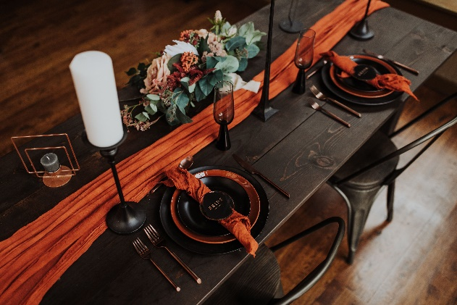
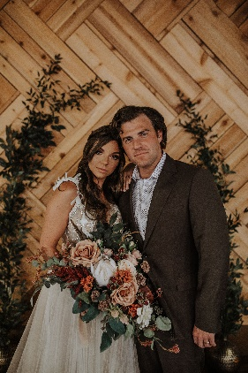
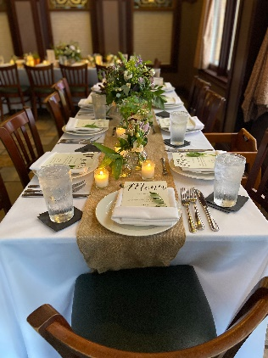
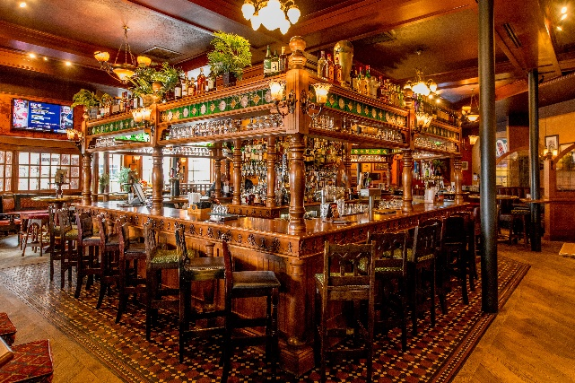

A Royal Wedding Experience
The Pub Orlando located in the heart of International Drive, is a great place to host a memorable and one-of-a-kind event. We are passionate about providing you and your guests with brilliant food, exceptional beverages, and genuine hospitality in an original and authentic atmosphere. Inspired by the classic British pub, The Pub Orlando offers a unique combination of British hospitality and royal flair. The award-winning exterior of The Pub is modeled after the classic and regal corners of London and the furniture and accessories provide an authentic British atmosphere.

The Pub Orlando offers a comprehensive rental package designed to bring your vision to life. Our packages include an air-conditioned ceremony and reception location and all the amenities below. Let our expert team take care of all your wedding needs and give you The Royal Treatment! Come across the pond, relax, and raise a pint at The Pub Orlando!

2 HOUR SET-UP & 6 HOUR EVENT TIME FRAME

Friday & Saturday Evening Minimum (6pm-12am) - $5,000++

Friday & Saturday Full Day Minimum (10am-4pm) - $3,500++

Sunday-Thursday Full Day Minimum (10am-4pm) - $2,500++

Entire Day Minimum (10am-12am) - $10,000++
(entire day package created for brides with a lot of setup or wanting to use The Pub as the Groom’s ready room)

All packages come with the following:

Onsite Coordinator
Wedding day itinerary and timeline
Oversee day of set up and breakdown
Manage rehearsal + logistics of wedding day

General Planning Checklist
Mahogany tables with black or white linens
Placement of personal Items + distribution
Temperature controlled one-of-a-kind venue

Package Options

The Windsor - $75++ | The Kensington- $150++
Plated menu including salad + two sides + one entree | Duel plated menu including salad + two sides + two entrees
Pipe and drape package | Professional wedding DJ or acoustic soloist and emcee
Dance floor | Pipe and drape package
Coffee service | Dance floor
Complimentary on-site parking for your guests | Champagne toast for all guests
Complimentary cake-cutting service | Complimentary valet parking for your guests
 | Coffee service
 | Complimentary cake-cutting service

Additional Packages

STANDARD BAR – three hours $35++ | five hours $50++

VODKA/GIN Absolut, Smirnoff, Beefeater, Tanqueray
RUM Bacardi, Malibu
WHISKEY/BOURBON Jim Beam, Seagram’s 7, Dewar’s, Johnny Walker Red
TEQUILA Sauza Silver, Cuervo Gold
BEER All Domestic and Imported
WINE All Trinity Oaks House Wine
ALL SOFT DRINKS Coffee, Soda, Un/Sweet Tea, Hot Tea

